

This document outlines The Wilderness Rangers School Programme for term 24/25 through facilitated sessions which we call “Quests”. It includes the goals, outlines, prices, and packages available to enquiring teachers.

Our schools programme motto is:

Engage. Enrich. Entertain.

Purpose and Goals

* To bring the wonders of the natural world into the classroom environment; focusing on local and global wildlife, ecosystems, and biological processes.
* To engage, enrich and entertain pupils on the outdoors - bringing experiences to them that were previously inaccessible.
* To encourage confidence and expression in pupils through active discussion and physical activity.
* To create an interdisciplinary learning experience to assist teachers in achieving their Experiences and Outcomes for their class.

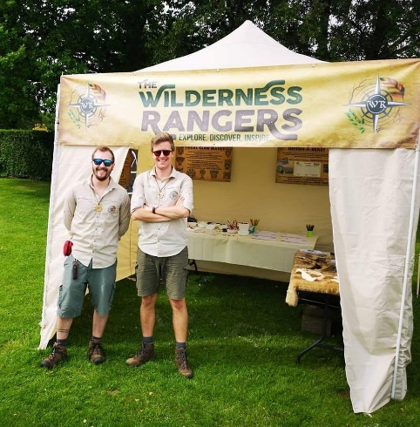

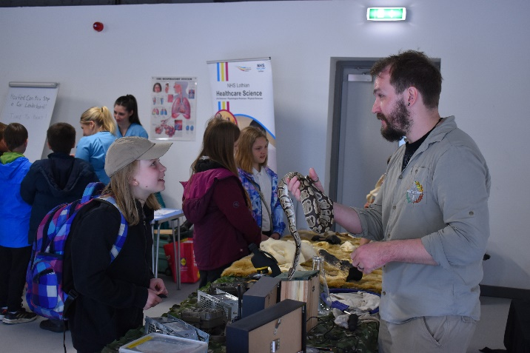

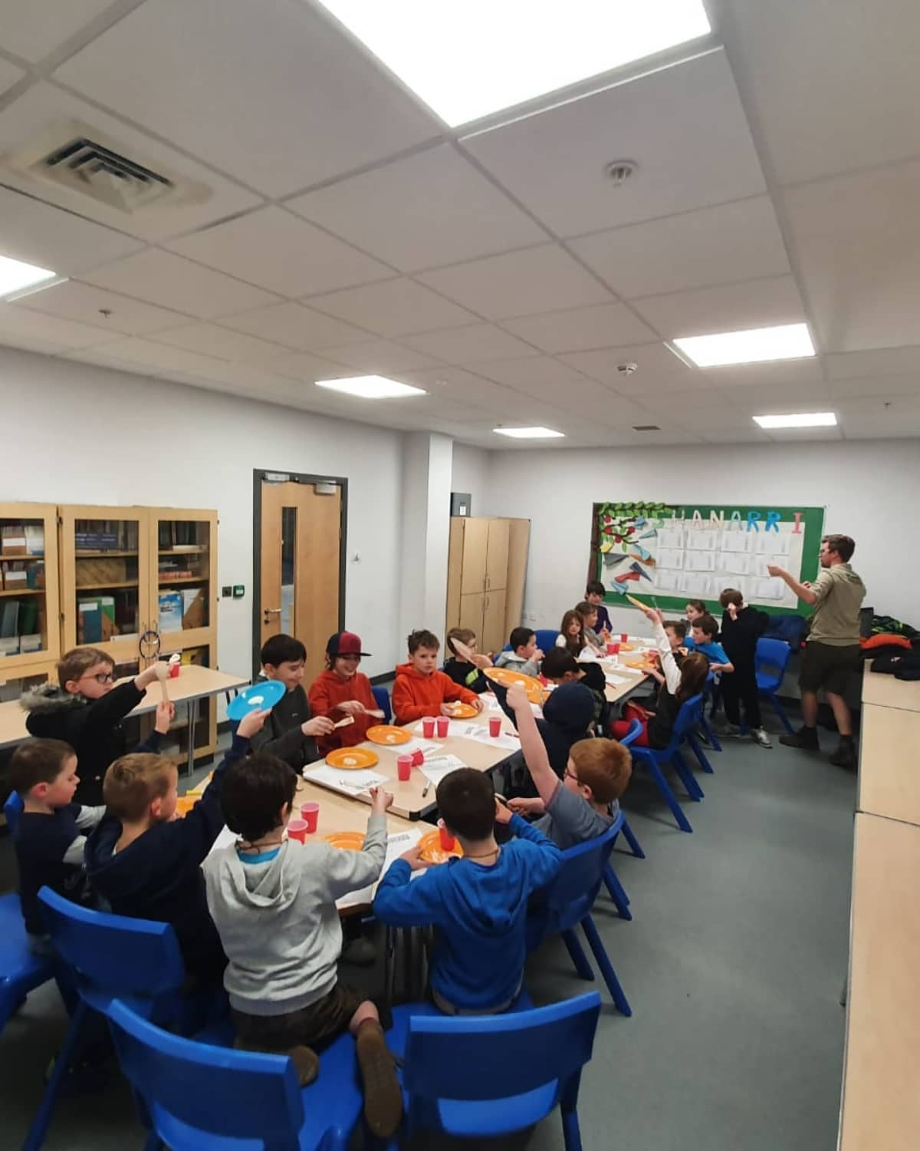Target Curriculum levels

The majority of our facilitated sessions are targeted to First Level (P2-P4) and Second Level (P5-P7) pupils.

We have a selection of tailored play-based and storytelling focused sessions for Early Level pupils.

We are also comfortable and familiar with enhancing any of our sessions to Third, Fourth and Senior level appropriately.

Experiences and outcomes (Es & Os)

Through our facilitated sessions led by our Chief Rangers, our most prominent Curriculum Area covered is Sciences.

Within Sciences, our unique learning approaches cover a wide range of Es & Os, including but not limited to;

* Planet Earth - Biodiversity and Interdependence, Energy Sources and Sustainability, Processes of the Planet, Space
* Biological systems - Body Systems and Cells, Inheritance
* Materials - Properties and Uses of Substances, Earth’s Materials, Chemical Changes

However, through our varied activities and packages, areas from across the Curriculum are explored, including but not limited to;

* Health & Wellbeing - Mental and Emotional Wellbeing, Social Wellbeing, Physical Wellbeing
* Expressive Arts - Participation in Performances and Presentations, Art and Design
* Social Studies - People, Place and Environment
* Physical Activity and Sport – Cooperation and Competition, Physical Activity and Health
* Literacy – Listening and Talking, Writing
* Numeracy – Number, Money and Measure, Information Handling,

“Quest” Outlines

The Wilderness Rangers School Programme is facilitated by two Chief Rangers and undertaken on-site - whether in the classroom, a larger hall, or on their external grounds.

Quests are specifically themed and can be made bespoke to each booking, allowing for relevant and complementary content to the pupils’ current learning goals.

Chief Rangers will arrive on site with all resources and equipment necessary, set up prior to the session, facilitate the session, provide any learning resources, then pack up and leave the site.

Quest Format

Quests can be booked by completing our booking form which will ask for;

* Number of pupils and teachers/adults that will be present
* Quest selected
* Start times preferred (AM or PM)
* Any appropriate SEN details of pupils
* Appropriate contact information

The school will then receive a reservation email for teacher’s confirmation.

Facilitators (“Chief Rangers”)

All sessions are led by our Chief Rangers. Chief Rangers Richard and Jordan have a wealth of knowledge and experience in environmental and science education, built up over the last decade. Having completed their studies, they travelled around the world on ecological research trips in locations such as Tobago, Florida and closer to home, all over Scotland. They have worked for incredible institutions such as The Royal Zoological Society of Scotland, SSPCA and the National Trust for Scotland in their careers. They founded The Wilderness Rangers in 2017 - now an award-winning education organisation, they undertake full-day outdoor Expeditions, half-day Ranger Adventures, phobia workshops, corporate and charity events and more, throughout Edinburgh and the Lothians!

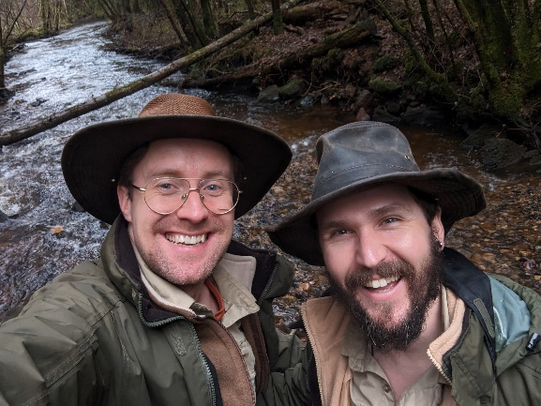

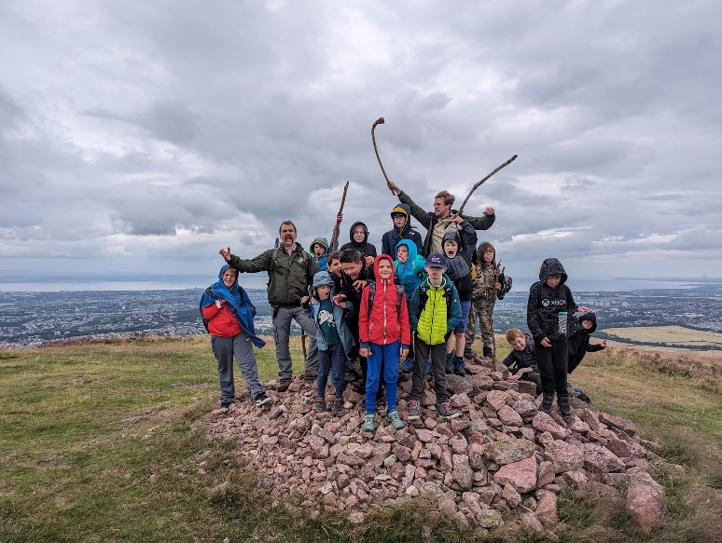

ON THE DAY

Chief Rangers will arrive on site with all appropriate equipment and resources as discussed in previous communications with lead teachers.

Chief Rangers will then facilitate the session.

All Quest packages are designed to last two hours and include a presentation element, a written resource or artistic craft element and, in many instances, a physical activity element (in the form of games and teamwork exercises).

All activities have been risk assessed by The Wilderness Rangers. Rooms in use should already be risk assessed by the teacher/school after being informed of intended activities.

At the end of the Quest, Chief Rangers will say their goodbyes, pack up any equipment or resources to take away (leaving any created work e.g. worksheets, crafts, artwork etc. for pupils).

Chief Rangers will then leave the site.

Pricing

The Wilderness Rangers aim for our Quests to be as affordable as possible to bring our unique experience to as many pupils as we can.

Quests are priced at £5.50 per pupil with any attending teachers or adults free of charge.

**Resources**

Each Quest will include a form of ‘take home’ resource directly beneficial to curricular learning. Dependent on the Quest selected, this could be a completed worksheet, a created piece of drawn artwork or a constructed object. Examples include ecosystem food webs, bird feeders, ‘design-a-beasts’, bug hotels, biological sketches, quizzes and more!

Resources will also be brought in to the classes on each Quest. These will compromise part of The Wilderness Rangers’ tools, equipment, and props within their extensive, specialised, collection. These will not go home with pupils, nor will they remain in the classroom after we leave, but offer an opportunity to see items that pupils will perhaps be unaccustomed to. These include examples such as replica skulls/taxidermy, wildlife tracking equipment, geological/paleontological samples, survival tools, biological sampling equipment to name but a few.

Choose your Quest!

Below is a list of our most popular QUESTS. Please remember, all QUESTS are crafted so that they can be tailored to the curriculum focus of the class to be relevant to their learning at that time.

Amazing Adaptations

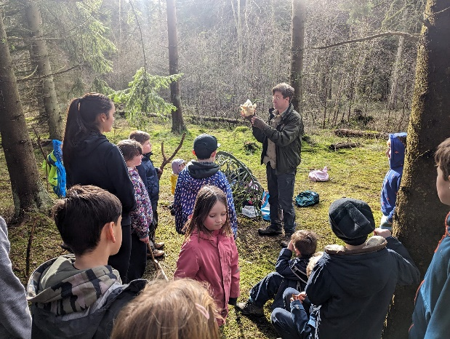Our most popular Quest, this session focuses on evolution and how animals around the world have adapted to different conditions and lifestyles to survive! Involves handling of animal samples such as skulls, feathers, horns, teeth with the option of a live animal handling session.

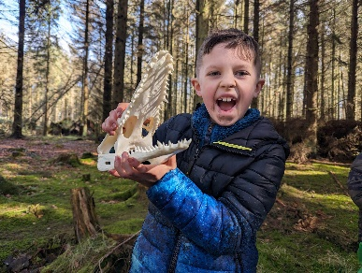

Ecosystem Explorers

Depending on the classes’ focus, this session examines ecosystems and habitats. It can be crafted and customised to cover everything from rainforests to deserts, tundra to mangroves. It includes a food web and food pyramid building activity as well as some surveying equipment and biodiversity artifact holding.

Mission Minibeast

An exploration of the hidden worlds all around us, inhabited by insects and other invertebrates. Discuss how different invertebrates are from us and examine their abilities. This session can involve a live animal handling element with minibeasts sourced from the great outdoors as well as exotic varieties. It can also involve the active minibeast hunt on any suitable grounds of the school.

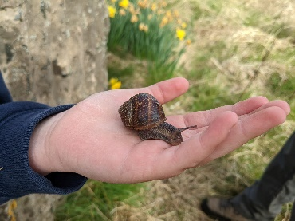

Powerful Plants & Fantastical Fungus

It’s time to get botanical! Pupils will learn about what makes plant life grow, why it is important, and can take part in a small potting activity where they go home with a mystery seed to monitor growth over time. Discussion is also taken to cover the importance of mushrooms, toadstools and why we should “give thanks to the fungus”.

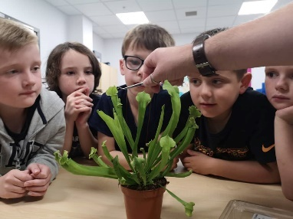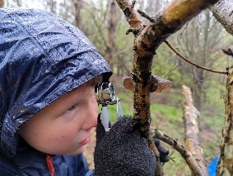

Operation Dinosaur

A comprehensive session covering archaeology and palaeontology. The session focuses on fossils and the global conditions that can lead to mass extinction events. Involves handling of real fossils as well as replica skulls and bones of extinct species.

Our Planet

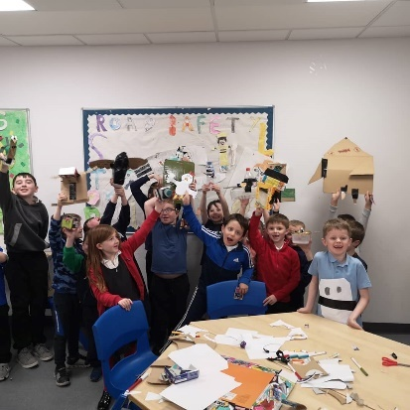A Quest examining Planet Earth’s geological history and the climate emergency we currently face in the modern world. Cover topics such as volcanoes, the water cycle, global warming, recycling, and wild weathers!

Our Place in Space

A session dedicated to our solar system and the impact we have on it as a species and as a planet! Discuss planetary bodies, black holes, events in space (e.g. meteor storms) and our cultural history with space exploration. Pupils will also take part in debates on whether other intelligent life is or is not out there in the cosmos.

Adventures in Anatomy

From digestion to nerves, the heart to the brain, this is a Quest to understand the inner workings of our own bodies. Explore the mechanisms and purposes of our organs and discuss processes such as the immune system through interactive play and crafts.

Voyage to the deep

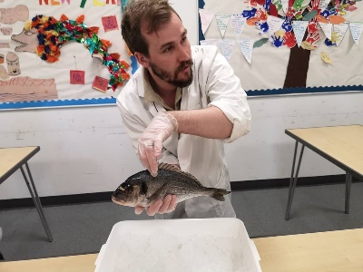We know more about the surface of Mars than our own deepest oceans! This session explores our planet’s oceans, seas, and freshwater bodies. Depending on the focus of the class, this session can cover anything from life in deep sea environments, tides and rockpools, human’s relationships with the sea (fishing, transport, recreation, research), myths and ancient beliefs, and more!

Early Years

We have three pre-designed packages specifically for Early Years learning groups.

* Seasonal sensory – Depending on the time of year, this Quest brings the outdoors, indoors to get up close and personal with some natural wonders. Whether its leaves and petals, pinecones and pebbles, nuts and berries, or shells and sand - Chief Rangers bring treasures to the table for everyone to enjoy. Through storytelling and games topics like pollination and life cycles can be discussed in an easily digestible manner.
* Minibeasts – Whether indoors or outdoors, its time to meet some wee beasties up close and personal! To break down any early phobias or misjudged opinions, our Chief Rangers will introduce the class to a number of critters they are likely to see in the garden or nearby their homes. Even includes the chance to have a real insect feast!
* Wildlife and the Weather – With the help of natural artifacts (and the option our friendly pet royal python Barry) learn about how different animals live around the world and how they survive when the weather changes! This session features plenty games and activities to learn what makes us hot and cold, or wet and dry and how humans have solved those issues!

Engage. Enrich. Entertain.

Contact and Enquiries

If you would like to get in touch to arrange a booking, or for any enquiries and discussions, please email us at thewildernesrangers@outlook.com

Social Media and Website

To see the other activities and packages The Wilderness Rangers deliver to Junior Rangers (including our extra-curricular half-day Adventures, and full-day Expeditions) please feel free to check out our Facebook page through the link below;

[Facebook.com/TheWildRangers](https://www.facebook.com/TheWildRangers)

You can also check out our website for a full run through of our other services such as birthday parties, as well as corporate and charity events and testimonials through the link below;

[The Wilderness Rangers](https://www.thewildernessrangers.co.uk/)